Utilizing the Thermal Energy from Natural Gas Engines and the Cold Energy of LNG to Satisfy the Heat, Power, and Cooling Demands of Carbon Capture and Storage in Maritime Decarbonization: Engineering, Enhancement, and 4E Analysis

Abstract:
The MEPC 80 session has revised the IMO GHG Strategy, setting more ambitious decarbonization goals. Carbon capture and storage (CCS) technologies have shown promise in reducing maritime carbon emissions, although their high energy requirements have often been neglected in previous research. This study introduces a novel system integrating a natural gas engine, CCS, an organic Rankine cycle (ORC), and a power turbine (PT). An exhaust gas bypass strategy is used to enhance engine performance at low and medium loads, channeling exhaust to the PT for power generation. The engine’s waste heat is fully utilized for CCS via cold, heat, and power. The study compares various absorbents in the CCS system, including monoethanolamine and piperazine solutions, which show different carbon capture efficiencies. Additionally, CO₂ storage conditions are analyzed and compared. The proposed system shows potential for significantly reducing the Energy Efficiency Design Index (EEDI) for general cargo ships. The study addresses the high energy demands of CCS by utilizing the engine's waste heat, transforming a potential drawback into a beneficial resource. By integrating the ORC and PT, the system not only captures carbon but also improves overall energy efficiency, presenting a promising solution for maritime decarbonization. The analysis of CO₂ storage conditions further enhances the understanding of effective carbon management. This innovative system demonstrates that with strategic integration and optimization, significant progress can be made towards achieving the stricter decarbonization targets set by the IMO, while also enhancing the energy efficiency of maritime operations.
Keywords: Greenhouse Gas Reduction; Recovery of Waste Heat; Marine Engine; 4E Analyses; Energy Efficiency Design Index.

1. Introduction:
According to the International Maritime Organization (IMO) [1], maritime transport, which facilitates almost 89% of global trade [2], is responsible for 2.88% of the total carbon dioxide output worldwide. As a result, the International Marine Organization has implemented several strategies to decrease emissions in the marine sector. These include the implementation of the Energy Efficacy Development Index (EEDI), the Energy Efficacy Existing Ship Indicator (EEXI), and the Carbon Intensity Index (CII) [3]. More precisely, the implementation of the EEXI began on January 1, 2023, as stated by Qu and colleagues [4]. Additionally, Stage III of the EEDI has been launched, as mentioned by Gutierrez-Romero and colleagues [5]. Moreover, the MEPC 80 session set more ambitious objectives, including two major targets [6]: a minimum reduction of 20%, with a goal of 30%, in overall yearly greenhouse gas (GHG) emissions from global shipping by 2030, compared to the levels in 2008, and a minimum reduction of 70%, with a goal of 80%, by 2040, also relative to 2008 [7].
Today, the use of renewable energy has become popular in most industrial processes and sectors such as building, agriculture, transportation, etc. [8, 9]. Biomass, solar, geothermal and wind energies are among the most well-known of these energy sources [10, 11]. The maritime sector is making significant strides toward eliminating carbon emissions entirely [12, 13]. Various methods to reduce carbon emissions have been suggested, including the use of substitute energy sources [14, 15], as well as the utilisation of sustainable and eco-friendly energy sources for instance, solar energy [16, 17] and wind energy [18], and the implementation of electrochemical storage systems [19]. Among these options, substitute energy sources have the greatest potential for immediate usage in marine environment applications due to their cost-effectiveness and feasibility [20, 21]. It is expected that natural gas will have a significant impact on the upcoming phase of the carbon-neutral plan due to its cost-effectiveness and widespread accessibility [22]. Nevertheless, it is important to acknowledge that while ammonia engines do not release CO2, they can nevertheless have a substantial influence on the greenhouse effect as a result of N2O and unburned NH3 emissions [23]. Maritime natural gas engines, being more advanced, are projected to become the dominant force in the low-carbon technology market in the upcoming years [24].
Although gas-powered engines represent progress in reducing carbon emissions, they still generate carbon dioxide, which poses a challenge to achieving near-zero emissions. In order to reduce the carbon footprint of maritime vessels, it is essential to utilize technologies such as Carbon Containment and Storage (CCS) and Waste Heat Reclamation (WHR) [25, 26]. These technologies have been identified as significant in mitigating the environmental impact, as supported by studies conducted by Jiang and colleagues [27], Park and colleagues [28], Zheng and colleagues [29], Baldasso and colleagues [30], Hoang [31], and Liu, Z. and colleagues [18]. In a recent study, Chu et al. [32] emphasised the crucial significance of sophisticated CCS (carbon capture and storage) technology in attaining near-zero emissions. They argued that relying just on renewable energy is insufficient to achieve net-zero emissions. Although the present expenses associated with CCS technology expenditures are substantial, they are anticipated to yield significant economic advantages in the long run. Three primary technological methods for carbon capture and storage (CCS) in maritime environments include post-combustion, pre-combustion, and oxyfuel technologies [33]. In their study, Yao and colleagues [34] described a sophisticated oxy-combustion CCS system that is specifically tailored for marine engines. This system effectively utilises waste heat from CCS to facilitate the evaporation of liquid natural gas (LNG). Their research revealed that the system could attain a carbon capture purity of 97.09%, an exergy efficiency of 51.78%, an output power of 318.36 kW, and an annual net profit of US$485,165. Furthermore, post-combustion carbon capture and storage (CCS) is especially well-suited for maritime natural gas engines because of the straightforward integration of the engine with the CCS system. Post-combustion processes generally exhibit higher carbon capture efficiency relative to pre-combustion and oxyfuel methods [35].
Feenstra and colleagues [36] investigated the application of a CCS (carbon capture and storage) system on LNG-powered ships. They discovered that the lowest possible expense for capturing and converting carbon dioxide into liquid form might be as little as 98 € per metric ton of CO2. Zhou et al. evaluated the efficacy of CCS systems with varying CO2 storage capacities, demonstrating that greater storage capacity resulted in reduced costs for liquefaction. Ros et al. [37] performed an economic evaluation of solvent-based CO2 capture for marine uses, demonstrating that onboard CCS systems have the ability to capture CO2 at a price of 118 €/ton CO2, achieving an efficiency rate of 72.6%. Long and colleagues [38] developed a carbon capture and storage (CCS) system specifically designed for marine diesel engines. The system achieved an impressive carbon removal efficiency of 94.7%, which is equivalent to 1349 kg/h. Liu et al. developed a controllable and rapid combustion concept for high power-density diesel engines [39]. Stec and colleagues [40] devised a post-combustion carbon capture and storage (CCS) system specifically designed for maritime applications, which also effectively eliminates sulfur dioxide (SO2). They emphasized that these systems have the ability to decrease CO2 emissions with minimal decrease in energy efficiency in extremely cold temperatures. They can achieve carbon recovery rates ranging from 31.4% to 56.5%, while still fulfilling the Energy Efficacy Development Index (EEDI) for the reference ship by 2025. Several research have concentrated on implementing CCS (Carbon Capture and Storage) systems in maritime settings. Post-combustion procedures encompass techniques such as physical adsorption [41], chemical absorption [42], and membrane technology [43].
Chemical absorption has demonstrated significant potential because of its reliable performance and capacity to manage large amounts of gas [44], [45], [46], [47]. In their study, Oh and colleagues [48] examined the effects of different sizes of Monoethanolamine (MEA)-based aboard carbon containment systems regarding exhaust gas parameters. They determined system scale had little influence on the reduction of CO2, indicating that smaller systems could potentially lead to cost savings. In their study, Manimaran et al. [49] investigated the utilization of phase change solvents to capture carbon from diesel engine exhaust. Specifically, they examined the effectiveness of two amino acids, L-alanine and L-arginine. These findings indicate that L-Alanine led to a reduction in CO2 emissions by 13.04%, while L-Arginine achieved a reduction of 21.73%. In their study, Luo et al. [50] devised a solvent-based CCS (carbon capture and storage) system specifically designed for cargo ships. This system successfully achieved a remarkable 73% decrease in carbon emissions from two 4-stroke engines, which collectively generated 17 MW of power. The cost of implementing this system amounted to 77.5 € per ton of CO2. In addition, they implemented an improved system that includes an additional power turbine, resulting in a carbon recovery rate of 90%, albeit at a higher expense. Multiple solvents are appropriate for absorption-based carbon capture and storage (CCS) devices. Nevertheless, post-combustion carbon capture and storage (CCS) systems require substantial quantities of Thermal energy and power. Zhao and colleagues [51] performed a thermodynamic assessment of the absorption-based carbon capture process, illustrating a technique for transferring thermal energy into electricity to enable chemical reactions. Kim et al. [52] devised and assessed a portable carbon capture device for commercial vehicles with the aim of reducing greenhouse gas (GHG) emissions. García-Mariaca and colleagues [53] suggested using an Organic Rankine Cycle (ORC) as a means to reduce the energy expenses linked to mobile engine carbon capture, resulting in a capture rate of 90%. In addition, the Organic Rankine Cycle (ORC) was able to decrease the energy penalty on the engine's power by a range of 3.9% to 13.9% as a result of the Carbon Capture and Storage (CCS) technology. Voice et al. [54] developed a carbon capture and storage (CCS) system tailored for internal combustion engines. This system effectively utilizes the engine's waste heat to maintain steady operation of the CCS system. These studies suggest that post-combustion, chemical capture, and liquefied containment CCS systems are highly likely to be beneficial for maritime natural gas engines. Nevertheless, they also emphasise the significant need for heat, cold, and electricity necessary for CCS operations. Numerous researches have investigated the utilisation of waste heat to fulfill the energy requirements of CCS systems. However, there is still a dearth of thorough and all-encompassing studies on the integration of engines, Waste Heat Recovery (WHR) systems [55], and CCS systems. Furthermore, in order to effectively absorb carbon dioxide in CCS systems, it is necessary to keep the temperature below 40°C. However, this need results in the inefficient use of low-temperature heat. No reports have been made regarding the utilisation of waste heat at low temperatures. Moreover, earlier studies on post-combustion CCS systems have failed to consider the requirement of cold energy for compressing carbon dioxide. Ultimately, there is a dearth of comprehensive solutions for aligning CCS energy requirements with the provision of heat, cold, and power derived from waste heat from engines and cold energy from LNG.
2. System description
Figure 1 illustrates the system being analyzed. This study focuses on a marine engine that runs on natural gas and operates at a medium speed. The precise details of the engine may be found in Table 1. At first, a fraction of the gas that is released from the cylinder (known as stream 22) is redirected in order to maintain a consistent and reliable performance of the turbocharger. The power turbine (PT) captures the remaining thermal and pressure energies from the redirected gas. In addition, the exhaust gas that comes out of the turbocharger (stream 1) is processed by chilling it using a concentrated solution (stream 6). Extracting CO2 from exhaust gas in an transmitter at a reduced temperatures is of utmost importance. Consequently, the exhaust gas that has been cooled (stream 2) experiences more cooling, resulting in the generation of some excess Thermal energy. The waste Thermal energy is subsequently harnessed by a straightforward Organic Rankine Cycle (ORC). Following a proper cool-down process, the exhaust gas (stream 3) is introduced into the absorber, resulting in the release of purified exhaust gas (stream 4). Inside the transmitter, carbon dioxide (CO2) from the exhaust gas interacts with either monoethanolamine (MEA) or piperazine (PZ) solution, resulting in the formation of a solution enriched with CO2 (stream 5) that exits the absorber. The enriched solution is first heated by the cooler, CO2-depleted solution (stream 8), after that with the exhaust gas (stream 1). Heated solution containing high levels of CO2 (stream 7) is subsequently introduced into the desorber, where the CO2 is extracted from the solution and released. The solution with reduced CO2 levels (stream 8) is chilled by the incoming solution with higher CO2 levels (stream 5) in a heat exchanger specifically constructed for solutions with different CO2 concentrations. This cooling process occurs before the solution re-enters the absorber to restart the cycle of absorbing CO2. The CO2 emitted from the desorber undergoes compression, cooling through seawater, dehydration, and ultimately complete liquefaction through LNG, before being stored in a CO2 tank. The desorption process is fuelled by the heat generated by the exhaust gas.

Table 1. Key specifications of the 8M23G natural gas engine.
Parameter | Value | Parameter | Value
Numbers of cylinder | 8 | Rating power | 1.6 MW
Bore | 0.23 m | Compression ratio | 13
Rating speed | 1000 rpm | Average pressure | 18.2 bar
Stroke | 0.32 m

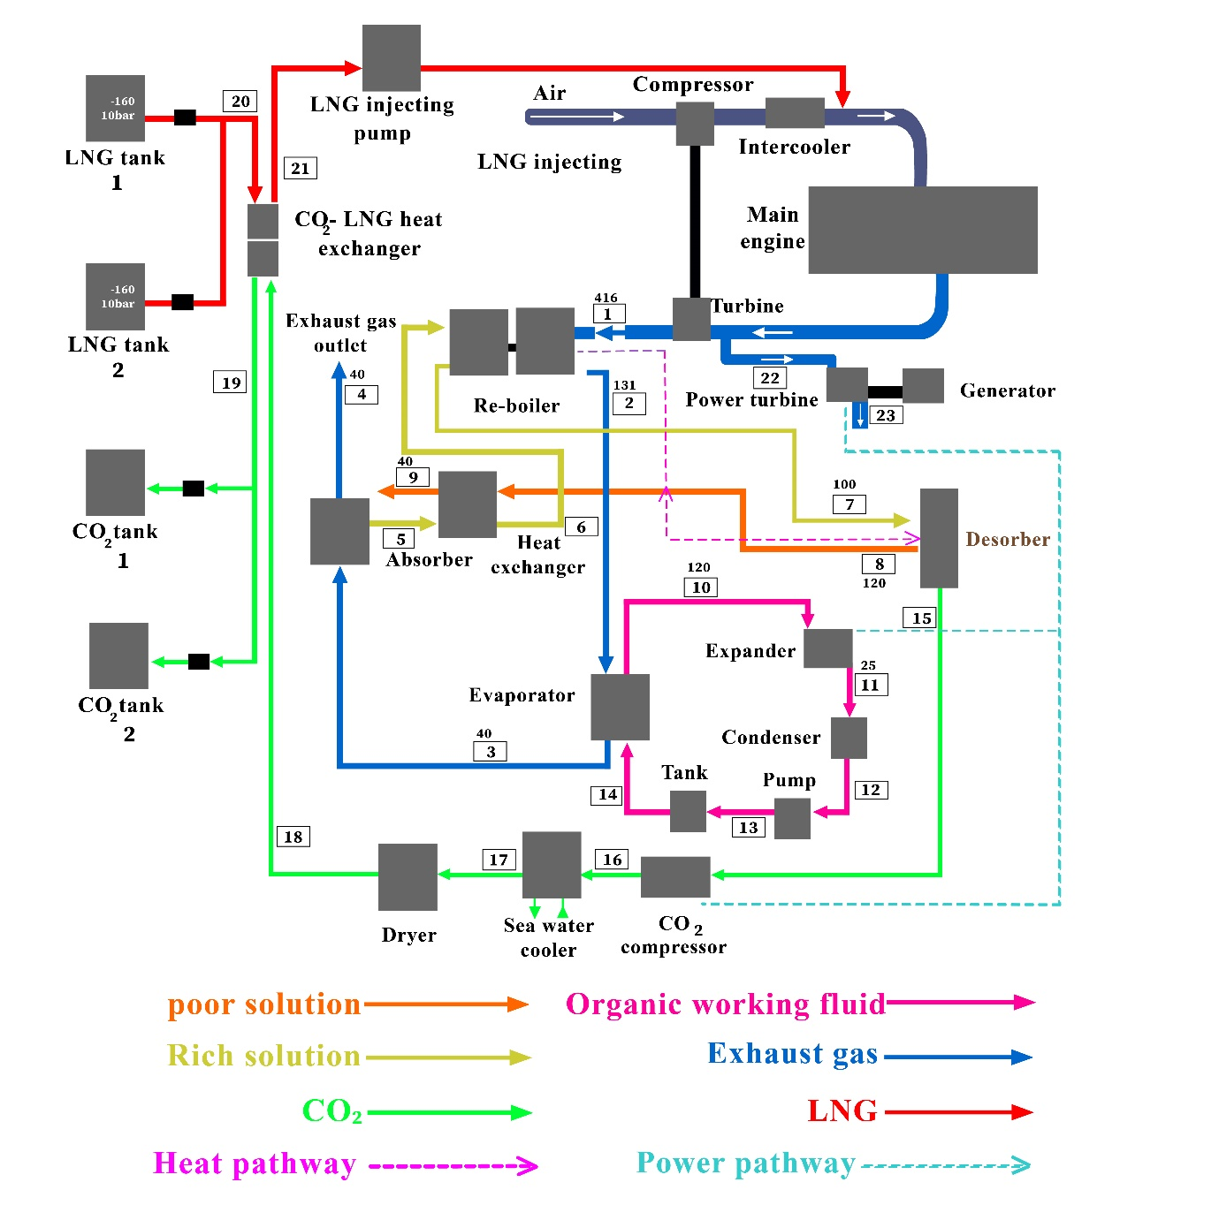

Figure 1. The illustration of the proposed energy system.

3. Approaches

3.1. Engine Evaluation

An engine evaluation was performed under atmospheric conditions with a temperature of 31.9°C and a humidity level of 54%. During this test, exhaust gas temperatures were measured upstream and downstream of the turbine, alongside the turbocharger speed, turbocharging pressure, and fuel usage.

3.2. Carbon Capture System Simulation

The study establishes a system-level Carbon Capture System model using Aspen Plus. The primary parts, the absorption and desorption units, are modelled using the RadFarc module, creating sub-models based on rate analysis. The HeatX module simulates the Thermal energy exchanger, and the Heater module is employed for the condenser [56]. The chemical reactions between MEA and CO2 are described below [57]:

$$2H_{2}O⇄H_{3}O^{+}+OH^{-}$$ | (1)

$$HCO_{3}^{-}+H_{2}O⇆CO_{3}^{2-}+H_{3}O^{+}$$ | (2)

$$HCO_{3}^{-}+H_{2}O⇆CO_{3}^{2-}+H_{3}O^{+}$$ | (3)

$$CO_{2}+OH^{-}→HCO_{3}^{2-}$$ | (4)

$$HCO_{3}^{2-}→CO_{2}+OH^{-}$$ | (5)

$$MEA+CO_{2}+H_{2}O→MEACOO^{-}+H_{3}O^{+}$$ | (6)
$$MEACOO^{-}+H_{3}O^{+}→MEA+CO_{2}+H_{2}O$$ | (7)
The reaction rate constant of CO2 absorption/desorption process has been simulated as following equation:

$$r=kT^{n}exp⁡(-\frac{E}{RT})\prod_{i=1}^{n}{C_{i}^{a_{i}}}$$ | (8)
In the given formula, $k$ is the pre-exponential coefficient, $T$ indicates the temperature, $E$ represents the activation energy, $R$ stands as the universal gas constant, and Ci and ai correspond the quantity and stoichiometric proportion of component i , respectively. The specifics of these responds are outlined in Table 2. Interactions between PZ and CO2 are described below [58]; [59]:

$$PZ+CO_{2}⇄H^{+}PZCOO^{-}$$ | (9)
$$H^{+}PZCOO^{-}⇄PZCOO^{-}+H^{+}$$ | (10)
$$PZCOO^{-}+CO_{2}⇆O^{-}OCPZCOO^{-}$$ | (11)
$$PZ+H^{+}⇄PZH^{+}$$ | (12)
Table 2. Variables of reaction period.
Parameter | Reaction-4 | Reaction-5 | Reaction-6 | Reaction-7
Activation energy | 55.4 kJ/mol | 123.1 kJ/mol | 41.2 kJ/mol | 65.5 kJ/mol
Pre-exponential factor | 4.32E+13 | 2.38E+17 | 9.77E+10 | 3.23E+19

The Carbon Capture model was verified using data from Ref. [60] to validate the precision of the model described in this paper. The model was tested under two different operational conditions, resulting in comparative discrepancies of 3.17% and 2.29%. These discrepancies primarily originate from not accounting for heat losses in the heat exchangers. There were also slight discrepancies in flue gas temperature and pressure across the two datasets. However, the model established in this study meets the set error criteria and provides a reliable analysis of the Carbon Capture System operations. The efficiency of the Carbon Capture System is evaluated using the reboiler load per unit mass of CO2, which is determined as follows:

$$q_{re}=\frac{Q_{re}}{m_{co_{2}}^{abs}}$$ | (13)
3.3. Simulation of ORC unit
A standard organic Rankine cycle is utilised to low-grade waste Thermal energy reclamation, depicted in Fig. 1 (stream 10-11-12-13-14-10). The evaluation of the organic Rankine cycle adheres to the principles of the first law of thermodynamics [61-63]. The thermal balance in the evaporator is characterised below:

$$W_{CO_{2}}=m_{co_{2}}\frac{k}{k-1}R_{g}T_{in}(1-π^{\frac{x-1}{x}})$$ | (14)
The net outlet energy of the ORC is determined below:

$$W_{net,ORC}=W_{E,ORC}-W_{P,ORC}$$ | (15)
The heat released by the condenser in the organic working fluid is calculated as follows:

$$Q_{c}=m_{w}(h_{12}-h_{11})$$ | (16)
The efficiency of the system is subsequently calculated as follows:

$$η_{e}=\frac{W_{net,ORC}}{Q_{h}}$$ | (17)
3.4 Exergy evaluation
This paper carries out an exergy analysis of the combined system. The techniques for examining exergy losses are outlined in Table 3. The reference environmental conditions are set at 26 degrees Celsius and under a pressure of 1 bar. Within this framework, WCO₂-1 signifies the power output of the first CO₂ compressor, WCO₂-2 represents the energy output of the second CO₂ compressor, Qq1 is the chilling Thermal energy of inter-cooler 1, Qq2 denotes the chilling Thermal energy of inter-cooler 2, and Ei expresses the exergy at stream i, computed below:

$$E_{i}=m_{i}(h_{i}-h_{i,0}-T_{0}\left(s_{i}-s_{i,0}\right))$$ | (18)
In this case, $h_{i}$ and $s_{i}$ denote the enthalpy and entropy at stream , respectively. Conversely, $h_{i,0}$, $s_{i,0}$ indicate the enthalpy and entropy of the constituent at stream i under standard environmental conditions. $T_{0}$ represents the ambient temperature.

Table 3. Exergy loss formulations for each element of the proposed system.
Component | Destructed exergy | Component | Destructed exergy
Turbine | $$E10-E11-WT,ORC$$ | Intercoller-1 | $$Q1+E15a-E15b$$
Condenser | $$E11-Qc-E12$$ | Intercoller-2 | $$Q2+E15c-E16$$
Pump | $$E12-E13+WP,ORC$$ | Compressor-First step | $$W1-E15-E15a$$
Desorber | $$E7-E15-E8$$ | Compressor-Second step | $$W2+E15b-E15c$$
Liquefier | $$E18+E20-E19-E21$$ | Evaporator | $$E2+E14-E3-E10$$
Absorber | $$E3+E9-E5-E4$$ | #HE-Rich-poor | $$E5+E8-E6-E9$$

3.5. Technical-economic analysis
This study performs a techno-economic analysis. The methodology for calculating the capital expenditure (CAPEX) is explained below [36]:

$CAPEX=\frac{FCI}{0.8}×\frac{i{(i+1)}^{n}}{{(i+1)}^{n}-1},(FCI=TDPC+TIPC$) | (19)
Table 3 details the methods used for analysing exergy loss. The reference conditions, or dead state, are set at 26 degrees Celsius and under a pressure of 1 bar. In this context, WCO2-1 and WCO2-2 are the power outputs of the first and second CO2 compressors, respectively. Qq1 and Qq2 are the cooling heat from inter-cooler 1 and inter-cooler 2, respectively. Ei is the exergy at stream i, computed as follows:
This document undertakes a techno-economic evaluation. The capital expenditure (CAPEX) is calculated using the approach described below [36]:

$CAPEX_{a}=\frac{CAPEX}{n}$ , ($OPEX=FOPEX+VOPEX)$ | (21)
Here, 'i' represents the interest rate and 'n' the service life. FCI stands for the fixed capital investment, TDPC denotes the total direct plant cost, TIPC represents the total indirect plant cost, and TEC stands for the total equipment cost. TEC can be estimated using Aspen Plus software. The annual capital expenditure is subsequently calculated as follows:
$TDPC=2.10×TEC$, ($TIPC=0.14×TDPC$) | (22)
Here, m_{fuel} represents the fuel consumption, W denotes the power input of the system, t refers to the operational time annually, and C_{fuel} is the cost of fuel. The costs associated with capturing carbon dioxide are calculated as follows:

$$CCC=\frac{CAPEX_{a}+FOPEX_{a}+VOPEX_{a}}{m_{CO_{2-a}}}$$ | (23)
Where mCO₂-a indicates the annual amount of carbon dioxide captured.

3.6. EEDI Calculation Approach
Lee and colleagues [64] devised a method for determining the Energy Efficacy Development Index (EEDI) for ships equipped with Carbon Capture and Storage (CCS) systems, detailed as follows:

$$EEDI=\frac{(\prod_{n}^{j=1}{f_{i}})(\sum_{nME}^{i=1}{P_{ME(i)}×C_{PME(i)}×SFC_{ME(i)}×f_{co_{2}})+\left(P_{AE}×C_{FAE}×SFC_{AE}\right)+PTI+EFF}}{f×V_{ref}×Capacity}$$ | (24)
In this framework, PME(i) denotes the power output of the main engine, CFME(i) indicates the carbon factor for natural gas, and SFCME(i) represents the specific fuel consumption of the main engine. PAE refers to the power output of the auxiliary marine generator set, CFAE is the carbon factor for the fuel used by the generator set, and SFCAE defines the specific fuel consumption of the marine generator set. V_{ref} is the vessel's design speed, Capacity is the design deadweight, m_{capture} quantifies the carbon captured, and m_{exhaust} specifies the mass flow rate of carbon dioxide in the exhaust gases. Additionally, the desired EEDI can be computed below:

$$EEDI_{required}=(1-X\%)×a×DWT^{-c}$$ | (24)
Here, X represents the decrement factor, whereas a and c denote coefficients meanwhile DWT stands for the vessel’s deadweight.
4. Findings
4.1. Results of Engine Testing
The Marine 8M23G gas-powered engines underwent testing within the specified boundary conditions for an integrated CCS-ORC-PT system. Table 4 demonstrates that the temperatures of the exhaust gas after the turbocharger were higher than 410 °C, suggesting the existence of waste heat of excellent quality that is appropriate for generating electricity using the Organic Rankine Cycle (ORC). Prior to entering the turbocharger, temperatures above 520°C were measured, highlighting substantial opportunities for power generation through Pressure Technology (PT).

Table 4. The findings related to engine exiting gas.
Parameter | Load
 | 50% | 70% | 90% | 100% | 110%
Mass flow rate of exhaust gas | 4590.43 kg/h | 6792.98 kg/h | 8108.1 kg/h | 9073.94 kg/h | 10203.72 kg/h
Exhaust gas Temperature-after turbocharger | 436.8 °C | 441.5 °C | 424.4 °C | 411.8 °C | 411.5 °C
Exhaust gas Temperature-before turbocharger | 515.4 °C | 554.6 °C | 562.72 °C | 571.4 °C | 585.3 °C
CO2-Mole fraction | 3.62% | 3.63% | 3.62% | 3.62% | 3.61%
CO2-Mass flow rate | 261.36 kg/h | 386.1 kg/h | 461.34 kg/h | 515.8 kg/h | 578.16 kg/h

4.2. Analysis of Parameters
4.2.1 Carbon Capture Unit
Figure 2 illustrates the impact of different mass concentrations of MEA and PZ absorbents on the system's performance. The mass flow rates of these solutions decreased from 6.66 kilograms per second and 6.12 kilograms per second to 4.35 kilograms per second and 4.46 kilograms per second, respectively, when the concentration was increased from 20% to 40%. The drop is related to the increased efficacy of the absorbents at greater concentrations, resulting in a reduction in the amount needed. However, greater amounts of MEA are linked to a heightened risk of corrosive harm. The boiling points of MEA and PZ solutions decreased from 121 °C to 122 °C and from 123 °C to 120 °C, respectively, as the levels increased. This discovery indicates that PZ solutions have a more consistent temperature response when the concentration is altered, unlike MEA solutions. Raising the temperature can lead to more intense chemical reactions, highlighting the need to control the concentration of absorbent mass to prevent the breakdown of MEA and PZ at high temperatures. Moreover, the energy requirement of the reboiler shows a fluctuating trend in response to changes in the mass concentration of the absorbent. This behavior is influenced by various factors such as the higher temperature required for reboiling and the lower rate at which the absorbents flow. These factors contribute to the observed pattern. Figure 2 illustrates that the ideal reboiler load is attained when the absorbent mass concentration is 30%, which is considered the benchmark.

a)

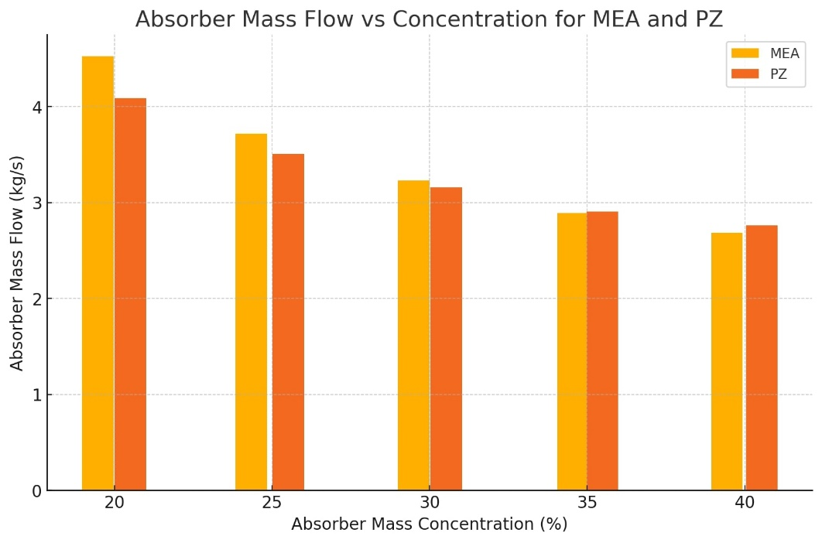

b)
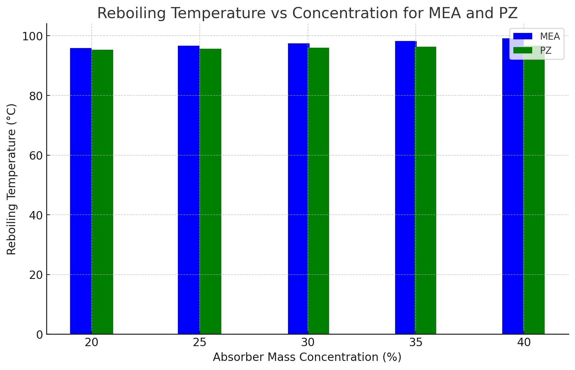

c)
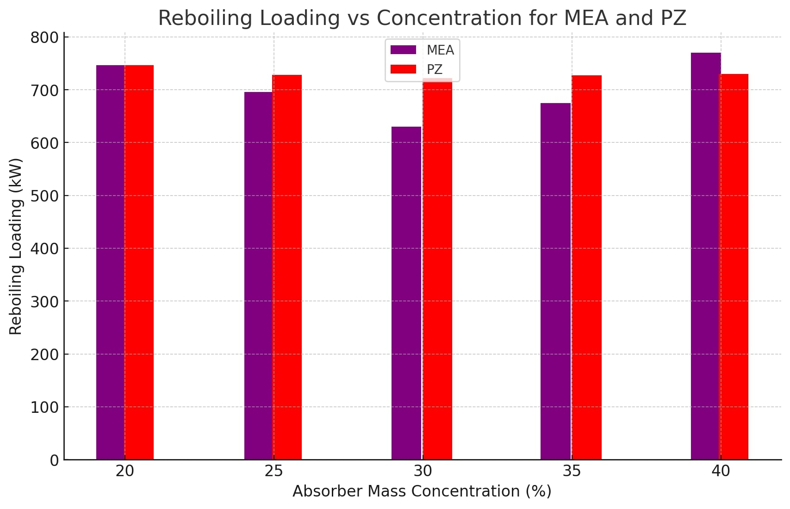

Figure 2. The impact of the absorption mass on (a) mass flow of the absorbent, (b) reboiler temperature, (c) loading of boiler
In addition, Figure 3 investigates the influence of CO2 content in the impoverished solution on the operation of the CCS system. The reversible nature of the process of absorbing and desorbing CO2 results in the presence of residual CO2 in the solution with low concentration. When the CO2 content in the inadequate solution increases from 0.16 to 0.29, the mass flow rate of the absorbent increases from 2.48 kilograms per second to 4.77 kilograms per second, and from 2.82 kilograms per second to 4.38 kilograms per second, respectively. This increase is a result of a decrease in the concentration of MEA or PZ. Furthermore, a rise in CO2 concentration leads to a drop in the reboiler load per unit of CO2 for the PZ solution. However, for the MEA solution, it initially falls and subsequently increases. Elevated levels of carbon dioxide (CO2) decrease the amount of water present, resulting in a drop in the amount of heat required for evaporation and, thus, a reduction in the amount of CO2 needed to operate the reboiler.
Raising the desorption pressure from 0.9 bar to 1.9 bar improves the rate at which CO2 is released, leading to a drop in the amount of cooling water required, a reduction in chilling Thermal power, and a rise in temperature from around 100°C to 120°C. Modulating the desorbing pressure is essential for maintaining an optimal temperature range. Moreover, raising the pressure at which desorption occurs reduces the amount of energy required per unit of CO2 in the reboiler. Specifically, for the MEA solution, the energy load decreases from 2443 kW/tCO2 to 1688 kW/tCO2, and for the PZ solution, it decreases from 2588 kW/tCO2 to 1916 kW/tCO2. An increase in desorbing pressures causes a shift in the equilibrium towards producing more CO2, reducing the amount of heat required for the desorption reaction. Nevertheless, higher desorbing pressures could elevate the energy demands for compressing and liquefying CO₂.

a)
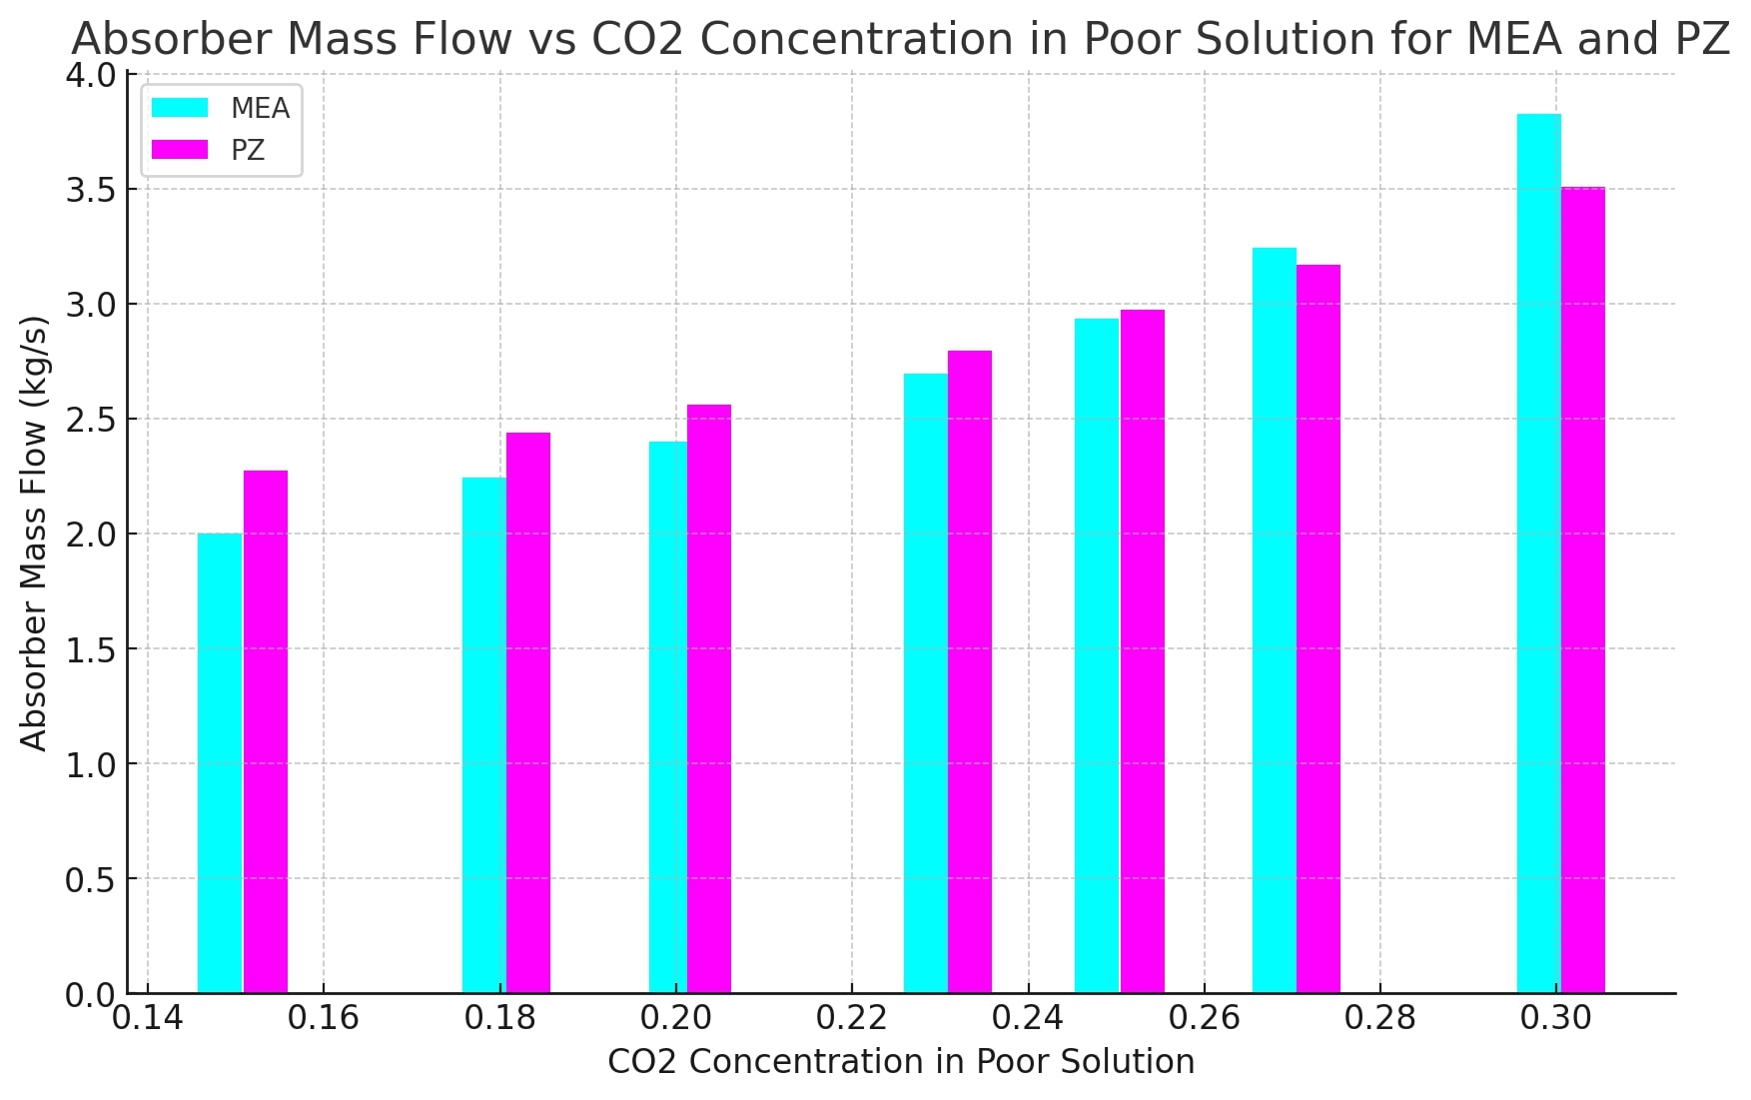
b)
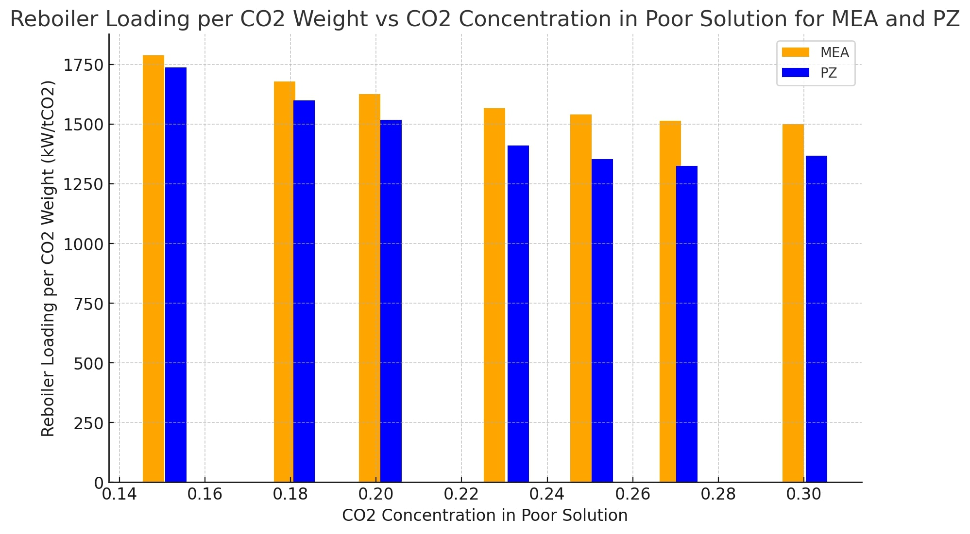
Figure 3. The impact of carbon dioxide in low solution on (a) absorbent mass flow and (b) the loading weight of reboiler.

4.2.2. Organic Rankine Cycle (ORC) Unit
The primary parameters that significantly impact the efficiency of the Organic Rankine Cycle (ORC) system are the pressures involved in the evaporation and condensation processes. The selection of organic working fluids is particularly critical, as they exhibit different evaporation temperatures at the same evaporating pressure. This study does a comprehensive examination of the evaporating and condensing temperatures in order to improve the heat integration between the exhaust gas and the ORC system. Figure 4 illustrates the impact of the evaporation temperature on the performance of the ORC. An increase in the evaporation temperature often leads to a decrease in the required mass flow rate of the organic working fluid. However, the extent of this reduction varies depending on the specific fluids being used. Moreover, a higher evaporation temperature initially results in an elevation and, subsequently, a decline in power production, with distinct peak values for each fluid. These fluctuations are probably associated with the energy needs of the pump. Higher evaporating temperatures result in increased evaporating pressures, which can generate a substantial rise in the enthalpy change for the pump, exceeding the changes for the expander. Furthermore, increasing the temperature at which evaporation occurs continuously enhances thermal efficiency. As the temperature at which the liquid turns into vapour increases, the amount of heat required for the Organic Rankine Cycle (ORC) decreases. Moreover, the power production and efficiency of the system are significantly influenced by the condensing temperature, as illustrated in Figure 4. An increase in condensing temperature typically leads to decreased power output and efficiency. The decrease is attributed to the rise in the pump's power demand, which surpasses the power increase caused by the expander. Due to the constant thermal input in the ORC, the overall efficiency also drops.
a)
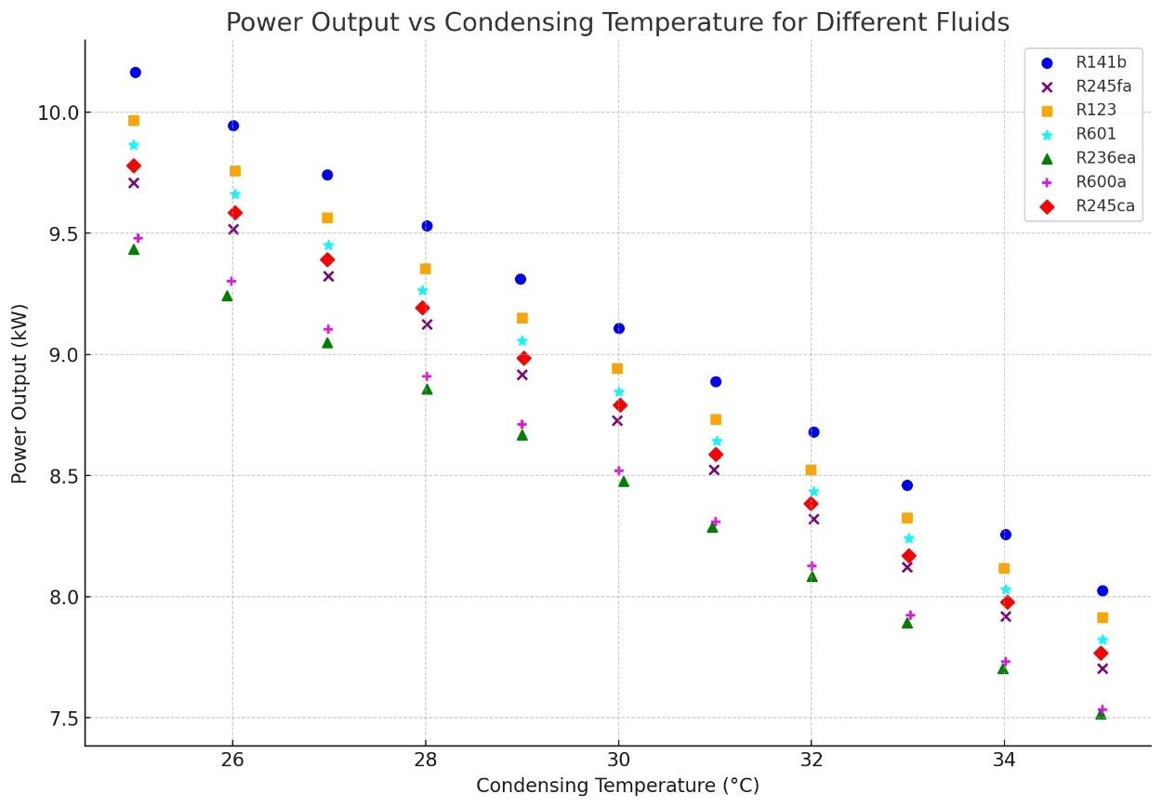
b)
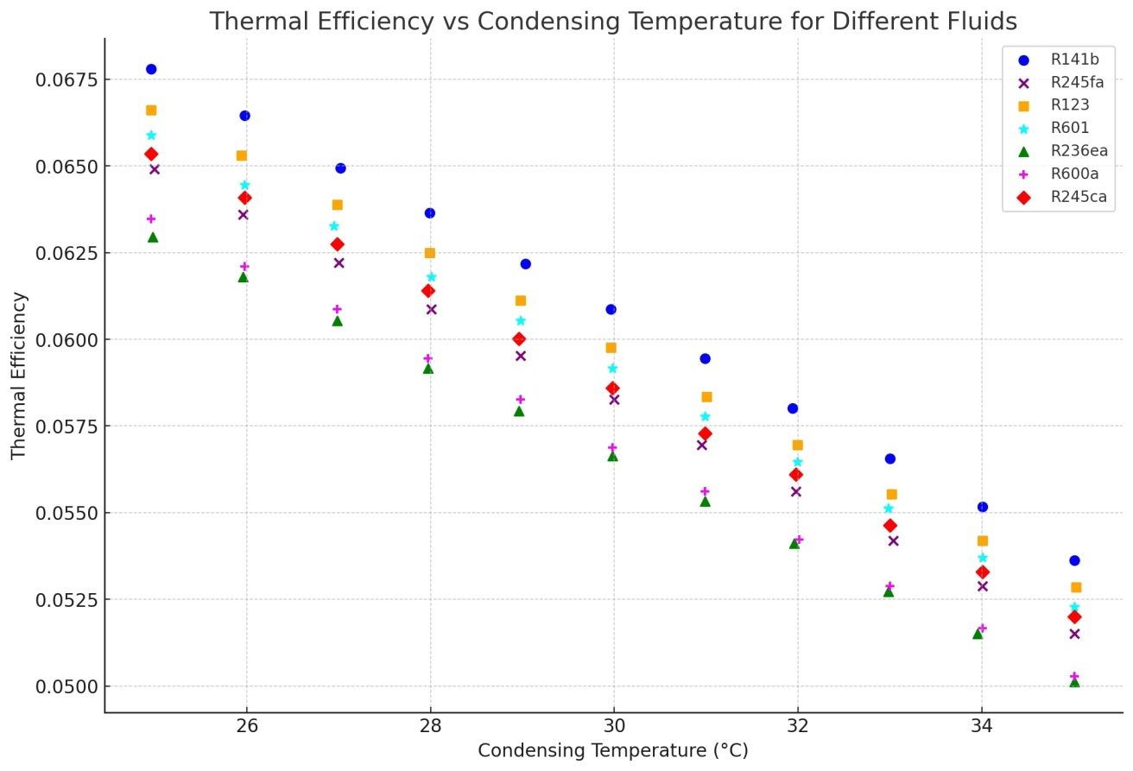
Figure 4. The impact of carbon dioxide in low solution on (a) absorbent mass flow and (b) the loading weight of reboiler.

5. Summary and Prospects
This paper presents a combined system that includes a Carbon Capture and Storage (CCS) system, an (ORC) system, and an energy turret. The purpose of this system is to reach the demanding carbon footprint drop goals established by the updated International Maritime Organization (IMO) Greenhouse Gas (GHG) Strategy. The initial research involves conducting engine tests and analyzing the combined system parameters. The main objective is to compare the efficiency of PZ and MEA solvents in two different CO₂ storage circumstances. The system integration carefully synchronizes the engine outputs with the heat, cold, and electrical needs of the CCS system. When examined from thermodynamic, techno-economic, and environmental viewpoints, the system shows significant promise in decreasing maritime emissions. The key findings indicate that the performance of the CCS system is greatly affected by the concentration of the absorbent, the level of CO2 in the depleted solution, and the pressure during desorption. The system's efficiency improves significantly as the concentration of CO₂ in the depleted solution increases and when higher desorption pressures is used. These factors substantially decrease the amount of heat needed for reboiling. The CCS system has determined the most efficient settings, which consist of a 30% concentration of absorbent, a depleted solution CO2 concentration of 0.4 mol CO₂/mol PZ (or MEA), and a desorption pressure of 2 bar. The sequestration rate obtained using a PZ solution vary from 61.40% to 92.95% for engine loads ranging from 110% to 50%. On the other hand, MEA solutions produce capture rates between 84.81% and 97.64%.
The Organic Rankine Cycle Power Turbine (ORC-PT) technology effectively fulfills the power needs of the CCS system by utilizing waste heat from exhaust gases. The energy outputs exceed 99 kW and 109 kW, respectively, under particular conditions. Exergy evaluations identify the main causes of exergy loss in the CCS system, particularly due to solution losses, which lead to a low exergy efficacy of 7.35%. Nevertheless, the exergy efficacy of the carbon dioxide compression and liquefaction processes has the ability to achieve a maximum of 54.86%, but the ORC system has a strong exergy efficiency of 68.78%.
Cost evaluations indicate that the CCS system incurs significant charges, mostly due to compression costs. On the other hand, the ORC system experiences substantially reduced expenses. The cost of capturing carbon dioxide depends on the selection of solvent and storage pressure. It can range from $196.20 per metric ton of CO₂ for a 12 bar-MEA configuration to $220.58 per metric ton of CO2 for a 23 bar-PZ configuration. This cutting-edge device provides a possible alternative for substantially mitigating carbon emissions from maritime vessels. The research employs a 7100-DWT general cargo ship to demonstrate that the suggested approach allows it to attain Energy Efficiency Design Index (EEDI) values that comfortably meet the Phase III criteria. The maximum decrease recorded in EEDI is 57.3%.
The present obstacles encompass the financial and energy effectiveness of the CCS system. Subsequent studies should prioritize enhancing these elements and more effectively incorporating Waste Heat Recovery (WHR) and CCS technologies modularly. Furthermore, it is crucial to tackle the issue of methane slip in order for CCS devices to successfully attain nearly zero emissions in maritime applications. Although it has some limits, this research sets the stage for a thorough comprehension and adoption of integrated technologies that could have a substantial impact on both market and policy frameworks in the maritime sector.

References

1. Joung, T.-H., et al., The IMO initial strategy for reducing Greenhouse Gas (GHG) emissions, and its follow-up actions towards 2050. Journal of International Maritime Safety, Environmental Affairs, and Shipping, 2020. 4(1): p. 1-7.
2. Okumus, D., et al., Towards a circular maritime industry: Identifying strategy and technology solutions. Journal of cleaner production, 2023. 382: p. 134935.
3. IMO, T., Guidelines on the method of calculation of the attained Energy Efficiency Design Index (EEDI) for new ships. 2018, International Maritime Organization London, UK.
4. Qu, J., et al., Assessment of a methanol-fueled integrated hybrid power system of solid oxide fuel cell and low-speed two-stroke engine for maritime application. Applied Thermal Engineering, 2023. 230: p. 120735.
5. Gutierrez-Romero, J.E., J. Esteve-Pérez, and B. Zamora, Implementing Onshore Power Supply from renewable energy sources for requirements of ships at berth. Applied energy, 2019. 255: p. 113883.
6. Feng, Y., J. Chen, and J. Luo, Life cycle cost analysis of power generation from underground coal gasification with carbon capture and storage (CCS) to measure the economic feasibility. Resources Policy, 2024. 92: p. 104996.
7. ISO, I., 14040. Environmental management—life cycle assessment—principles and framework, 2006: p. 235-248.
8. Ghasemi, A., H.N. Rad, and F. Golizadeh, A low-carbon polygeneration system based on a waste heat recovery system, a LNG cold energy process, and a CO2 liquefaction and separation unit. International Journal of Low-Carbon Technologies, 2024. 19: p. 654-666.
9. Rad, H.N., et al., Evaluating energy, exergy and economic aspects of a CO 2-free Kalina cycle cogeneration system with various solar collectors. International Journal of Low-Carbon Technologies, 2024. 19: p. 892-907.
10. Ghasemi, A., et al., Exergoeconomic and exergoenvironmental analyzes of a new biomass/solar-driven multigeneration energy system: An effort to maximum utilization of the waste heat of gasification process. Thermal Science and Engineering Progress, 2024. 48: p. 102407.
11. Rad, H.N., A. Ghasemi, and M. Marefati, Cost and environmental analysis and optimization of a new and green three-level waste heat recovery-based cogeneration cycle: A comparative study. Heliyon, 2024.
12. Nejati, M.G., et al., Life cycle analysis (cost and environmental) of different renewable natural gas from waste procedures based on a multivariate decision-making approach: a comprehensive comparative analysis. International Journal of Low-Carbon Technologies, 2024. 19: p. 339-350.
13. Demir, N., et al., A low-carbon multigeneration system based on a solar collector unit, a bio waste gasification process and a water harvesting unit. International Journal of Low-Carbon Technologies, 2024. 19: p. 1204-1214.
14. Dey, S., et al., A comprehensive study on prospects of economy, environment, and efficiency of palm oil biodiesel as a renewable fuel. Journal of cleaner production, 2021. 286: p. 124981.
15. Liu, L., et al., Investigation of combustion and emissions characteristics in a low-speed marine engine using ammonia under thermal and reactive atmospheres. International Journal of Hydrogen Energy, 2024. 63: p. 1237-1247.
16. Zhu, Y., et al., Influences of solar energy on the energy efficiency design index for new building ships. International Journal of Hydrogen Energy, 2017. 42(30): p. 19389-19394.
17. Zhu, C., et al., An innovative process design and multi-criteria study/optimization of a biomass digestion-supercritical carbon dioxide scenario toward boosting a geothermal-driven cogeneration system for power and heat. Energy, 2024. 292: p. 130408.
18. Liu, F., F. Sun, and X. Wang, Impact of turbine technology on wind energy potential and CO2 emission reduction under different wind resource conditions in China. Applied Energy, 2023. 348: p. 121540.
19. He, G., et al., The economic end of life of electrochemical energy storage. Applied energy, 2020. 273: p. 115151.
20. Bilgili, L., A systematic review on the acceptance of alternative marine fuels. Renewable and Sustainable Energy Reviews, 2023. 182: p. 113367.
21. Zhu, C., et al., Optimization, validation and analyses of a hybrid PV-battery-diesel power system using enhanced electromagnetic field optimization algorithm and ε-constraint. Energy Reports, 2024. 11: p. 5335-5349.
22. Cao, J., et al., Investigation on jet controlled diffusion combustion (JCDC) mode applied on a marine large-bore two-stroke engine. Journal of Cleaner Production, 2023. 429: p. 139546.
23. Sánchez, A., M.M. Rengel, and M. Martín, A zero CO2 emissions large ship fuelled by an ammonia-hydrogen blend: Reaching the decarbonisation goals. Energy Conversion and Management, 2023. 293: p. 117497.
24. Jang, H., et al., Demystifying the lifecycle environmental benefits and harms of LNG as marine fuel. Applied Energy, 2021. 292: p. 116869.
25. Sun, W., et al., Analysis of the main influencing factors of waste heat utilization effectiveness in the tank storage receiving process of waxy crude oil under dynamic liquid level conditions. Renewable Energy, 2024. 228: p. 120707.
26. Zhu, C., et al., Optimizing solar-driven multi-generation systems: A cascade heat recovery approach for power, cooling, and freshwater production. Applied Thermal Engineering, 2024. 240: p. 122214.
27. Jiang, Y., et al., Energy-effective and low-cost carbon capture from point-sources enabled by water-lean solvents. Journal of Cleaner Production, 2023. 388: p. 135696.
28. Park, S., et al., Cost optimization methodology based on carbon-techno-economic analysis: An application to post-combustion carbon capture process. Journal of Cleaner Production, 2024. 434: p. 139887.
29. Zheng, C., X. Wu, and X. Chen, Low-carbon transformation of ethylene production system through deployment of carbon capture, utilization, storage and renewable energy technologies. Journal of Cleaner Production, 2023. 413: p. 137475.
30. Baldasso, E., et al., Organic Rankine cycle-based waste heat recovery system combined with thermal energy storage for emission-free power generation on ships during harbor stays. Journal of cleaner production, 2020. 271: p. 122394.
31. Hoang, A.T., Waste heat recovery from diesel engines based on Organic Rankine Cycle. Applied energy, 2018. 231: p. 138-166.
32. Chu, B., et al., A long-term impact assessment of carbon capture (storage) investment conducted by conventional power company on sustainable development. Applied Energy, 2024. 358: p. 122567.
33. Davoodi, S., et al., Review of technological progress in carbon dioxide capture, storage, and utilization. Gas Science and Engineering, 2023: p. 205070.
34. Yao, S., C. Li, and Y. Wei, Design and optimization of a zero carbon emission system integrated with the utilization of marine engine waste heat and LNG cold energy for LNG-powered ships. Applied Thermal Engineering, 2023. 231: p. 120976.
35. Thaler, B., et al., Optimal design and operation of maritime energy systems based on renewable methanol and closed carbon cycles. Energy Conversion and Management, 2022. 269: p. 116064.
36. Feenstra, M., et al., Ship-based carbon capture onboard of diesel or LNG-fuelled ships. International Journal of Greenhouse Gas Control, 2019. 85: p. 1-10.
37. Ros, J.A., et al., Advancements in ship-based carbon capture technology on board of LNG-fuelled ships. International Journal of Greenhouse Gas Control, 2022. 114: p. 103575.
38. Long, N.V.D., et al., Improvement of marine carbon capture onboard diesel fueled ships. Chemical Engineering and Processing-Process Intensification, 2021. 168: p. 108535.
39. Liu, L., et al., Concept of rapid and controllable combustion for high power-density diesel engines. Energy Conversion and Management, 2023. 276: p. 116529.
40. Stec, M., et al., Reducing the energy efficiency design index for ships through a post-combustion carbon capture process. International Journal of Greenhouse Gas Control, 2021. 108: p. 103333.
41. Ben-Mansour, R., et al., Carbon capture by physical adsorption: materials, experimental investigations and numerical modeling and simulations–a review. Applied Energy, 2016. 161: p. 225-255.
42. Salih, H.A., et al., Hybrid–Slurry/Nanofluid systems as alternative to conventional chemical absorption for carbon dioxide capture: A review. International Journal of Greenhouse Gas Control, 2021. 110: p. 103415.
43. Chakrabortty, S., et al., Green synthesis of MeOH derivatives through in situ catalytic transformations of captured CO2 in a membrane integrated photo-microreactor system: A state-of-art review for carbon capture and utilization. Renewable and Sustainable Energy Reviews, 2023. 182: p. 113417.
44. Ding, S. and Y. Liu, Adsorption of CO2 from flue gas by novel seaweed-based KOH-activated porous biochars. Fuel, 2020. 260: p. 116382.
45. Leung, D.Y., G. Caramanna, and M.M. Maroto-Valer, An overview of current status of carbon dioxide capture and storage technologies. Renewable and sustainable energy reviews, 2014. 39: p. 426-443.
46. Mumford, K.A., et al., Review of solvent based carbon-dioxide capture technologies. Frontiers of Chemical Science and Engineering, 2015. 9: p. 125-141.
47. Wang, M., et al., Post-combustion CO2 capture with chemical absorption: A state-of-the-art review. Chemical engineering research and design, 2011. 89(9): p. 1609-1624.
48. Oh, J., et al., Optimal capacity design of amine-based onboard CO2 capture systems under variable marine engine loads. Chemical Engineering Journal, 2024. 483: p. 149136.
49. Manimaran, R., et al., Post combustion carbon capture from diesel engine exhaust using phase change solvents with absorption technique. Materials Today: Proceedings, 2022. 66: p. 1424-1430.
50. Luo, X. and M. Wang, Study of solvent-based carbon capture for cargo ships through process modelling and simulation. Applied Energy, 2017. 195: p. 402-413.
51. Zhao, J., et al., Decoupled thermal-driven absorption-based CO2 capture into heat engine plus carbon pump: A new understanding with the case study. Energy, 2020. 210: p. 118556.
52. Kim, J., et al., Design and assessment of a novel mobile carbon capture system: Energy and exergy analyses. Energy Conversion and Management, 2024. 300: p. 117934.
53. García-Mariaca, A., E. Llera-Sastresa, and F. Moreno, Application of ORC to reduce the energy penalty of carbon capture in non-stationary ICE. Energy Conversion and Management, 2022. 268: p. 116029.
54. Voice, A.K. and E. Hamad, Evaluating the thermodynamic potential for carbon capture from internal combustion engines. Transportation Engineering, 2022. 10: p. 100144.
55. Basem, A., et al., Technical and financial feasibility of a chemicals recovery and energy and water production from a dairy wastewater treatment plant. Scientific Reports, 2024. 14(1): p. 11143.
56. Zhu, C., et al., Simulation and comprehensive study of a new trigeneration process combined with a gas turbine cycle, involving transcritical and supercritical CO2 power cycles and Goswami cycle. Journal of Thermal Analysis and Calorimetry, 2024: p. 1-24.
57. Mun, J.-H., et al., Optimal MEA/DIPA/water blending ratio for minimizing regeneration energy in absorption-based carbon capture process: Experimental CO2 solubility and thermodynamic modeling. Chemical Engineering Journal, 2022. 444: p. 136523.
58. Lim, H., et al., Carbon dioxide capture in aqueous potassium serinate and piperazine solution using bubbling reactor for membrane contactor applications. Journal of Industrial and Engineering Chemistry, 2023. 122: p. 200-209.
59. Stowe, H.M., E. Paek, and G.S. Hwang, First-principles assessment of CO 2 capture mechanisms in aqueous piperazine solution. Physical Chemistry Chemical Physics, 2016. 18(36): p. 25296-25307.
60. Dugas, R.E., Pilot plant study of carbon dioxide capture by aqueous monoethanolamine. 2006.
61. Ayadi, B., et al., Multi-criteria/comparative analysis and multi-objective optimization of a hybrid solar/geothermal source system integrated with a carnot battery. Case Studies in Thermal Engineering, 2024: p. 104031.
62. Bai, L., et al., A new biomass-natural gas dual fuel hybrid cooling and power process integrated with waste heat recovery process: Exergoenvironmental and exergoeconomic assessments. Process Safety and Environmental Protection, 2023. 176: p. 867-888.
63. Marefati, M., M. Mehrpooya, and F. Pourfayaz, Performance analysis of an integrated pumped-hydro and compressed-air energy storage system and solar organic Rankine cycle. Journal of Energy Storage, 2021. 44: p. 103488.
64. Lee, S., et al., Novel methodology for EEDI calculation considering onboard carbon capture and storage system. International Journal of Greenhouse Gas Control, 2021. 105: p. 103241.

